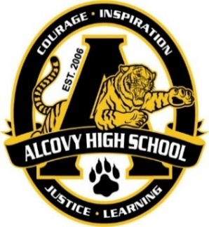
Gina Clark
Karen Gibbs
Thomas Lowe
Assistant Principals
Alcovy High School
14567 Highway 36
Covington, GA 30014
Telephone: (770) 784-4995
Fax: (770) 784-4996
Kristopher Williams, Ed.D.
Principal

Greetings Tiger Parents:

Alcovy High School is constantly striving to maintain the best possible learning environment for our students. Any conditions that distract students from learning is of serious concern. Therefore, we would like to take this opportunity to reinforce the dress code policy as stated in the NCSS handbook.

- No chain links, or studded belts that could be used as a weapon.
- Pants/skirts shall be worn at the waist level so as not to show skin or undergarments.
- Clothing which advertises or displays any insignia of alcohol, illegal drugs, or tobacco.
- Clothing with obscene, vulgar, or suggestive language or design.
- Clothing with words or symbols, such as pictures and emblems, which advocate violence and/or terrorism.
- Clothing with signs, symbols, drawings, or writings which show allegiance, affiliation, or reference to any non-sanctioned group.
- Colors, bandannas, articles of clothing or paraphernalia which promote or identifies with a non-sanctioned group.
- Sunglasses, caps, hats, and other head-coverings such as bandannas and hoods worn
- Clothing that exposes or accentuates the upper or lower body, such as spandex pants, uncovered leggings, see-through garments, halter tops, tank tops, spaghetti straps, backless dresses, tube tops, muscle shirts, or shirts or blouses that are tied at, or may rise above, the waist.
- Garments with holes that expose undergarments or significant amounts of flesh above the knee.
- Shorts, dresses, or skirts less than fingertip length when worn properly around the waist and when standing upright.
- This includes splits in skirts.
- Clothes that expose underclothing or impedes walking.
- Shoes that are unsafe for transition or school activities, including shoes with wheels.
- Sleep wear including, but not limited to pajama sets, gowns, bathrobes, slippers, blankets, etc..

A well-disciplined and orderly school is necessary for a safe learning environment to exist and is the right of every student and teacher. Please review all expectations with your child (ren) to reinforce AHS dress code expectations. Students who fail to comply with the dress code guidelines will be referred to an administrator. Consequences will be given according to AHS dress code rules. Parents will be contacted for support.

Respectfully requested,
Dr. Kristopher William, Principal

